Select shareit for settings

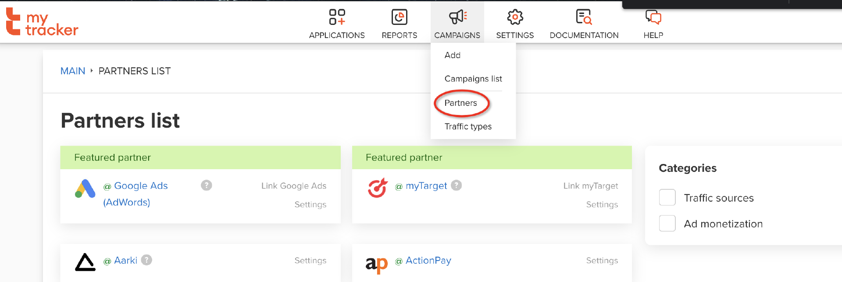

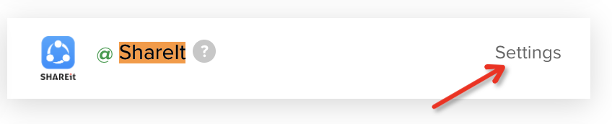

Configure Install postbacks

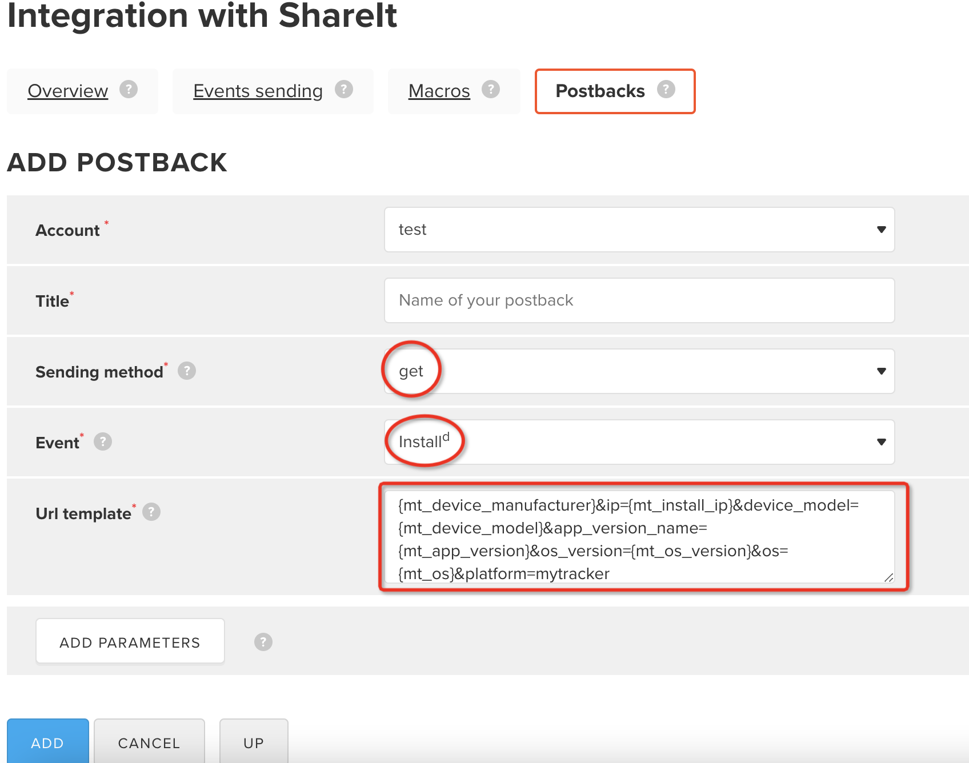

install

|  |
| --- |
| https://ping.rqmob.com/postback?clickid={clickid}&gaid={mt_gaid}&android_id={mt_android_id}&appid={mt_bundle_id}&click_ts={mt_click_ts}&country_code={mt_install_country_code}&device_brand={mt_device_manufacturer}&ip={mt_install_ip}&device_model={mt_device_model}&app_version_name={mt_app_version}&os_version={mt_os_version}&os={mt_os}&platform=mytracker |

Configure Re-Install postbacks

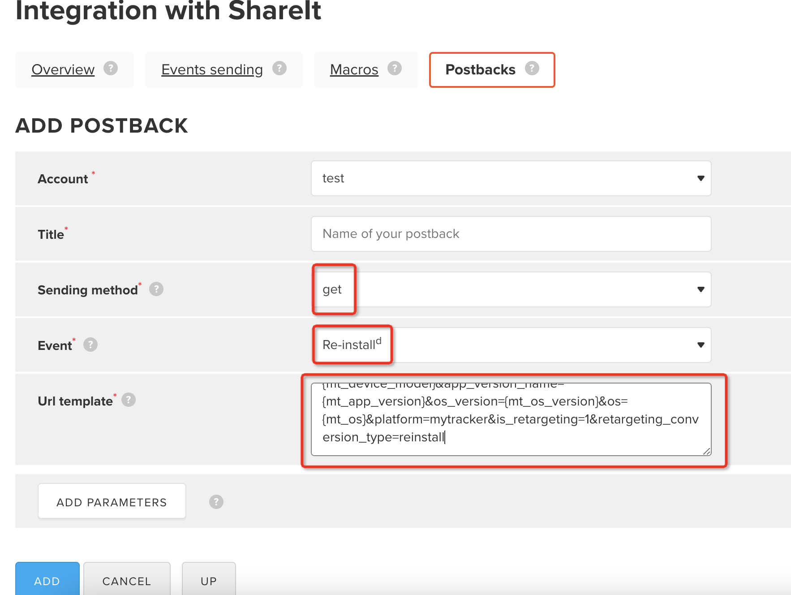

reinstall

|  |
| --- |
| https://ping.rqmob.com/postback?clickid={clickid}&gaid={mt_gaid}&android_id={mt_android_id}&appid={mt_bundle_id}&click_ts={mt_click_ts}&country_code={mt_install_country_code}&device_brand={mt_device_manufacturer}&ip={mt_install_ip}&device_model={mt_device_model}&app_version_name={mt_app_version}&os_version={mt_os_version}&os={mt_os}&platform=mytracker&is_retargeting=1&retargeting_conversion_type=reinstall |

re-engagement

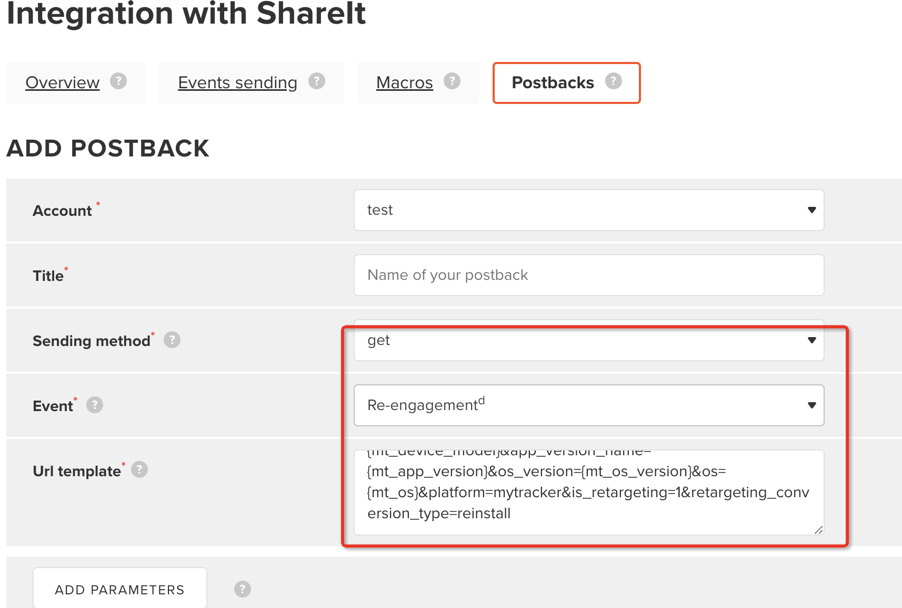

|  |
| --- |
| https://ping.rqmob.com/postback?clickid={clickid}&gaid={mt_gaid}&android_id={mt_android_id}&appid={mt_bundle_id}&click_ts={mt_click_ts}&country_code={mt_install_country_code}&device_brand={mt_device_manufacturer}&ip={mt_install_ip}&device_model={mt_device_model}&app_version_name={mt_app_version}&os_version={mt_os_version}&os={mt_os}&platform=mytracker&is_retargeting=1&retargeting_conversion_type=reengagement |

event is the same as above

|  |
| --- |
| https://ping.rqmob.com/event?clickid={clickid}&event_name={mt_event_name}&country_code={mt_event_country_code}&device_brand={mt_device_manufacturer}&ip={mt_event_ip}&traffic_source={mt_traffic_source}&mt_traffic_type={mt_traffic_type}&platform=mytracker |

open postback

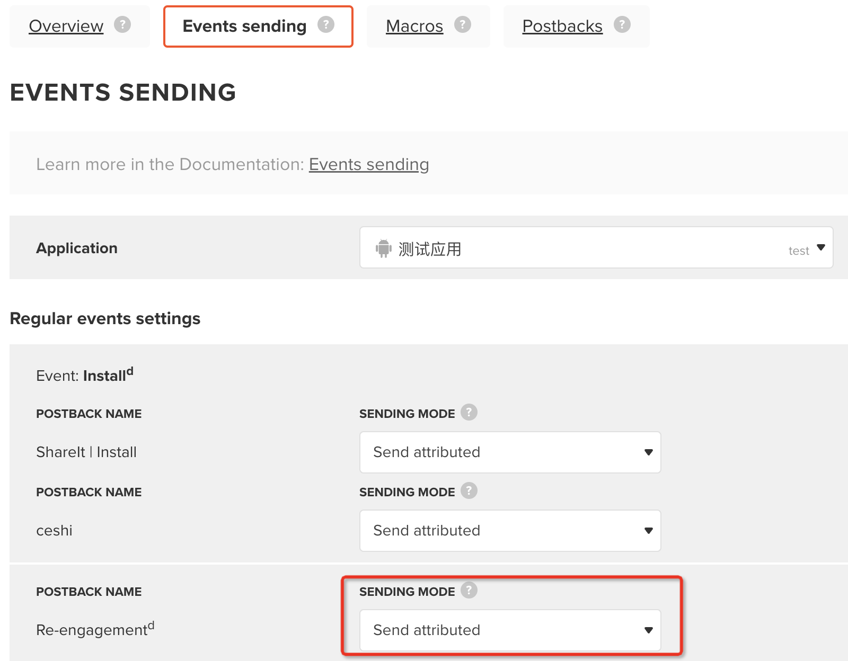

Create an attribution link

